Securities Back office Processing
First Digital Bank

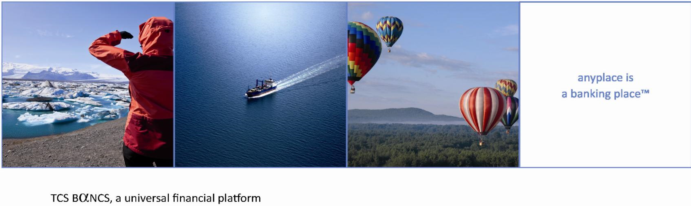

Copyright

No part of this document may be reproduced in any form, including video recording, photocopying, download, broadcasting, or electronic transmission, without prior written consent of Tata Consultancy Services. Copyright protection includes content in the material generated from software programs displayed on the screen, such as icons, screen displays, and so on.

Confidentiality

Information contained in this material is confidential and proprietary to Tata Consultancy Services and may not be modified, copied, published, disclosed, distributed, displayed or exhibited, in either electronic or printed form without written authorization of the Project Manager, TCS BaNCS, Tata Consultancy Services.

Trademarks

TCS BaNCS is a registered trademark. All other trademarks that appear in the document have been used only for identification purposes and belong to their respective companies.

Acronyms & Abbreviations

The following abbreviations and Acronyms are used in this document.
Abbreviation/Acronym | Description
FDB | First Digital Bank
TCS | Tata Consultancy Services
FI | Financial Instruments
BO | Back Office
FO | Front Office
SI | Service Integrator
MI | Market Information Module of BaNCS.
PS | Pricing Services

Version History
Version | Date  ( DDMMMYYY) | Author | Remarks
1.0 | 13-JUL-2021 | Virender Beniwal | Initial Version.

Revision details
Version | Action taken  (add/del/change) | Change description

Reviewer Details
Version | Date | Name | Role | Location

Approver Details
Version | Date | Name | Role | Location

Contents
1 Contents 5
1.1 Security Product Setup 5
1.2 Security Rate creation 5
1.2.1 Security Rates 6
2 Security Orders 6
3 Trade Cycle 7
3.1 Tase Trade Settlement Lifecycle 7
3.2 Foreign Trade Settlement Lifecycle 10
3.3 Extranet Trades 11
3.4 Order Amendments (Post Execution) 11
3.4.1 Cancel Existing Order 11
3.4.2 Existing Order (Change or Correction) 12
3.4.3 Missing Order (New Order Capture) 12
3.5 Fractional Order (for left over fraction, full sell) 13
3.6 MF trading 14
4 Stock Transfers 15
4.1 Type of Stock Transfers 16
4.1.1 Within Bank 16
4.1.2 Between different Banks 17
4.1.3 Delivery In/Out 20
5 Cash and Security Movement creation Flow 20
6 Tax Engine 22
7 Charges/Commission 22
7.1 Custody Fee 24
8 Position Recon 25
8.1 Local Securities 25
8.2 Foreign Securities 25
8.3 Tax Engine (local + Foreign) 25
9 BackOffice Reports 25
10 Messages 27

Contents

Security Product Setup

The Financial Instrument component of BaNCS acts as source for receiving and maintaining the products and their properties from various sources like TASE, Bloomberg and Magna.
Local Securities from Tase
Security Type value in Bancs | Description in Bancs
1 | EquityInstrmnts
2 | DebtInstruments
3 | Rights
4 | Warrant
54 | TBills (makam)
58 | IndexCrtfct
60 | Fund
229 | Exchange Traded Fund
333 | HiTechFund
901 | FOREIGN ETF

Detailed Mapping attached w.r.t to tase table 143.
Foreign Securities from Orbis/Bloomberg
Security Type value in Bancs | Description in Bancs
1 | EquityInstrmnts
3 | Rights
4 | Warrant
58 | IndexCrtfct
229 | Exchange Traded Fund

Security Rate creation

The Market Information component of BaNCS acts as the single source for receiving, maintaining, and distributing market/official rates and other dynamic data [like Yield/duration/ratings/recommendations etc.] of securities, Forex, and Inter-bank rates. BaNCS can interface with various rate providers for uploading the online rates as well as closing rates.

Security Rates
Security rates received from a rate feed agency through an interface, can be uploaded into BaNCS. Security rates can also be manually entered either for a particular security or for multiple securities via mass entry feature.
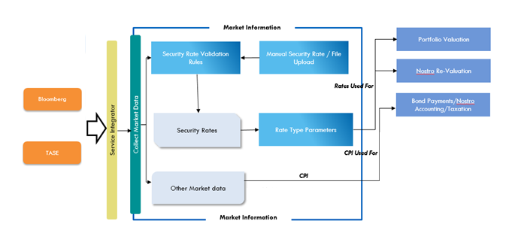

Security Orders
BaNCS facilitates processing of different types of Buy/Sell orders for products like Equity, bonds, Mutual funds, ETF’s etc. & SIP for Funds from capturing the order till the full execution or valid end status (based on customer Modifications during the order validity period)

High Level Order & Trade Workflow
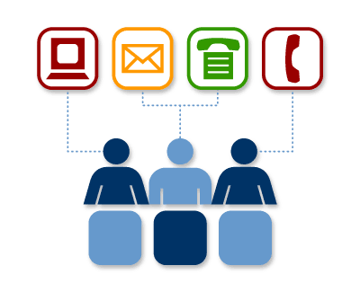
1. Orders
Channels
Order Management & Routing
2. Validation
Market
3. Place Order
4. Trade Execution
Trade Execution
5. Enriched Trade
Trade Settlement
6. Position
Clearing House
8. Settlement
7. Trade
Accounting
9. Movements
10. Settlement

Validations
- Buying Power (for Buy Order)
  - Whether Customer is having sufficient Balance for Buy
- Security Balance (For Sale Order)
  - Whether customer is having enough security for sale
- Product Subscription
  - Whether customer has subscribed to the particular asset type trading.
- Limits & Market parameters for the trade quantity, price etc.
- Trading Calendar for Funds

Blocks
- Power of attorney (for buy/ sell/ CA order s, DF/RF)
  - A bank employee, who is also a POA, cannot trade or take securities related actions on the account for which he is appointed without the approval of another FDB party.
- Correction/fraction portfolio (for buy/ sell/ CA orders, DF/RF)
  - Correction between a correction account and a client account can only occur after 4-eyes approval. Once Approved, batch will process and settle ( covered under order amendment)
- After the set time, the nostro cannot leave an open order .
Once the above validations and blocks are passed, order is confirmed in the system “Authorized Status”, and response is sent to ST. Upon receiving confirmation from Market via ST, order is moved to “Placed with Market” Status.`
Upon the receipt of executions from the market the ST Allocations, ST Deals are captured, cash/custody blocks are updated accordingly. Order moves to “Partial executed” status. When the final execution is received the order is marked as “Executed”. Customer can modify/cancel the order before the final execution.
Attached is the document which depicts the flow in case of modifications and cancellations taking place during the order execution.

Trade Cycle

Local Trade Settlement Lifecycle

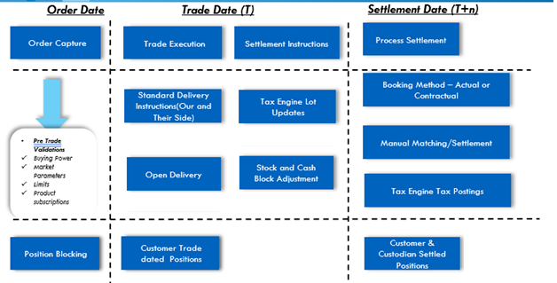
- Trades will be received from TASE through ST-SP interface. As part of trades processing, system will update order with executed quantity and will generate he stock movements for client portfolio.
- For purchase orders, Cash blocks will be adjusted, and release date will be updated for executed portion of cash block.
- For sale orders, custody block will be removed, and entry will be created in sale proceeds table. This amount will be available in buying power of portfolio.
- Order with future validity dates if not executed on current business day, are handled by FO, FO will push those order to market every business day in the morning, until the order is executed or expired whichever is earlier.
- File 1051 will be received on trade date and will be used for reconciling trade records received during the day. Matching will be done basis of following fields:
  - Instrument
  - Quantity
  - Execution Id
  - Price
  - Trade date
- For deals matched with 1051 file, system will update reconciliation status as “Reconciled” at deal level. For unmatched deals, status will be updated as “Not Matched”.

- Report will be provided to user for mismatch trades:
  - Orders are available, but no trades are captured in Bancs
  - Trades present in BaNCS, but not reported in1051
  - Orders and trades not available in Bancs for records reported in 1051

- File 1054 will be used for identifying failed/pending trades. Reconciliation status will be updated as Failed/ Pending (ST deal + Open delivery) based on data received in 1054 file. Following are details of processing required:
  - Buy trade
    - User will manually block custody positions in customer account.
  - Sale trades
    - User will manually create cash blocks in customer account. System will allow cash block creation for amount more than available balance in cash account.
- After settlement release of cash/custody blocks will also be a manual process.
- Client-side cash movements will be done on contractual or actual (According to the bank's decision( basis by batch program on transaction settlement date. The ‘Actual model’ can be simulated by running the client settlement batch close to 1052 processing
- Contractual/Actual is supported at system level for customers and cannot be defined per market/exchange
- In case a trade is marked failed by stock exchange user will manually cancel order from “ST Order list” screen. This cancellation will reverse all movements and cancel order, deal, allocation, and open delivery records.
- File 1052 will be used for street side cash and stocks processing.
  - System will create settlement advice transactions for records received in 1052 file and will match them with trades /stock transfer open deliveries.
  - Settlement advice will not be created again if the settlement advice with same TASE movement id, Event id, Security id, Quantity and price already exits.
  - If manual matching is done for an open delivery it will not be part of reconciliation after that.
  - User will be able to track the un-matched events using the open delivery and settlement advices list screens.
  - Settlement process will run on predefined time and do the Street side settlement for all matched open deliveries.
  - Matching status will be stored at open delivery and settlement advice level.

- Screen for linking of unmatched open deliveries and settlement advice records. Instrument id will be mandatory criteria for matching (Error to be raised in case instrument different between open delivery and settlement advice)

- Manual matching screen layout will be as follows:

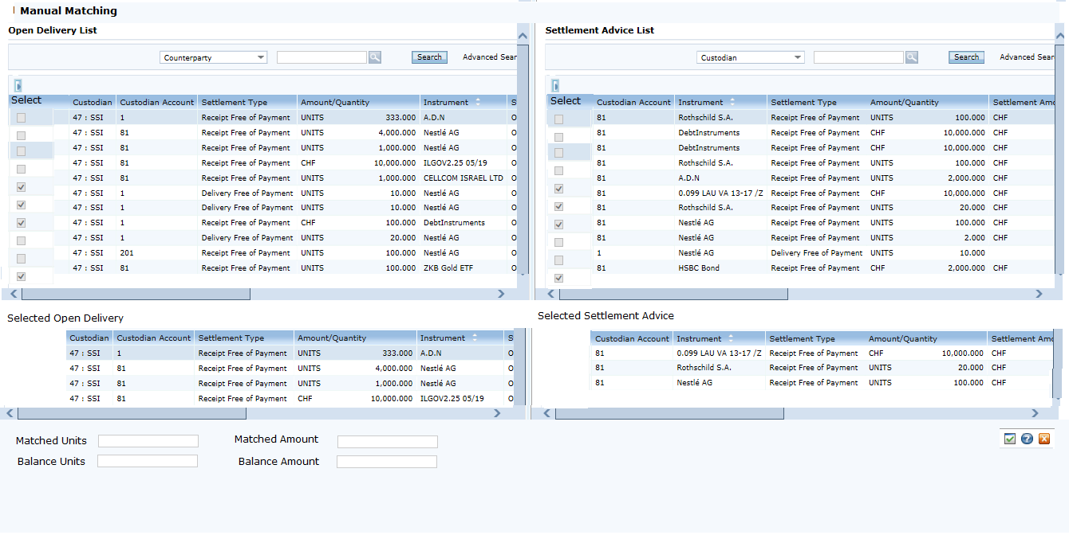

- System will validate the following fields for selected open delivery and settlement advice records:
  - Quantity
  - Instrument
  - Custodian
  - Amount (Tolerance will be applicable as per existing functionality of specify tolerance at custodian role level).
  - Settlement Type
- System will generate nostro side cash and stock positing as part of matching event.
- Net Settlement
  - TASE provides following files for net settlement and fee
    - File 31 – CA net settlement (Will be managed by CA component)
    - File 32 – Trade and transfer net settlement
    - 1091 – Detailed TASE charges supporting the charges in file 31/32
  - Tase File 32/1091 will be uploaded in Bancs for Securities Retail and Nostro trades. No processing will be done,on the files i.e. the data will be stored in BaNCS as-is32 file report will be produced on the last file received from TASE for each file (“D” in record 01) attached the report mapping according to the fields of each record type. 1091 report will at trade level with Commission charges in Bancs And coming in tase file 1091, Also a column for the difference in the charges will be presented. The Files can be routed to by GoAnywhere to multiple destinations. For BO, BI System.
  - () Report Format attached.

  - File 1091 reconciliation depends on TASE trading charges setup feasibility
    - If TASE trading charges can be setup then BaNCS will reconcile the 1091 data vs data from BaNCS for trading only and show the difference.
    - As of now no TASE charges will be setup for transfer or CA and hence these charges will always come as mismatch in recon process
    - If TASE trading charges can’t be setup then BaNCS will provide a data extract using which Bank will need to calculate charges and match the same manually with 1091.
    - File 32 also has total charges being reported in the file and reconciliation for that also depends on the feasibility of TASE trading fee setup

Foreign Trade Settlement Lifecycle

- Trades will be received through ST-SP interface. As part of trades processing, system will update order with executed quantity and will generate the securities movements for client portfolio.
- For purchase orders, Cash blocks will be adjusted, and release date will be updated for executed portion of cash block.
- For sale orders, custody block will be removed, and entry will be created in sale proceeds table. This amount will be available in buying power of portfolio.
- Bancs Front Office will process a Broker file at EOD.

  - FO system will match broker order reference and for each of the orders cancel all the existing trades in the BaNCS system and capture one average price trades as per the details available in the file. The trade cancellation and new average price trades will also be sent to Back office. As part of the trade information, FO will send all the charges (Broker commission, SEC & TAF) in separate tags along with principal amount.
14 | Comm | Number | (21,7) | Broker Commission
16 | TAF | Number | (21,7) | Third Party Fee

SEC Fee will be charged to the customer along with the commission as per setup. Will be separated and marked as 3rd party fee in customer’s account.

- The file ‘Broker order summary’ will be uploaded into Bancs and will be used to generate the mismatch report only for bank BO team. Any missing or extra orders in BaNCS will be shown to the user on the report
Following setup will be done in the system
- Following fee setup will be done in the system
- Customer Side Fee: This fee will be applied based on commercial condition linked to the customer portfolio
  - ST Commission
- Broker Side Fee : These will be setup under broker fee package and the same will be linked to the broker BP
  - Broker Commission

  - TAF Fee

SEC Fee will be charged to the customer along with the commission as per setup. Will be separated and marked as 3rd party fee in customer’s account.
The accounting rule will be setup as per below mentioned Rule
Principal – Customer account Vs Broker settlement account
ST Commission - Customer account Vs Fee Income (Will form part of cost price)
SEC Fee - Customer account Vs 3rd party account (Will form part of cost price, segregated from the FDB fee. Will be marked as 3rd party fee in customer’s account).

Broker Commission, TAF – Fee Expense vs Broker settlement account.

- Deal and OD will be marked as Matched and their execution done.

  - Below two scenarios will be handled manually by BO operations team.
    - In case an order is not present in the system, Same should be part of the Trade Recon report next morning.
    - In case an order is not present broker file, Same should be part of the trade recon report next morning. Can be figured out with the deal status, if it’s not matched then should be part of the report.

- Customer Cash settlement will be done by batch program on T+1 based on exchange settlement cycle.
- As of now there is no settlement confirmation file or message available from the custodian (APEX) and hence street Side Settlement will be done post position and cash reconciliation
- Bancs processes customer and street (market) side movements as different business processes. For foreign market, to settle the street side transaction, a new batch process will be written, that will do the street side cash movements. While doing the movements the batch will mark the OD (Open Delivery to Settled Status) which were matched and recon’d earlier by the Broker’s order summary file uploaded in the bancs for foreign trades cancellation/re-capture at EOD for a single execution.
- Deals captured manually based on recon report will need be updated for reconciliation status also so that these deals are also settled in the batch process
- Net Settlement

  - Currently APEX provides file 869 & 870 for confirming final net settlement amount. We are not able to process the files as these files have broadridge codes and APEX is not able to provide us the logic to translate the codes to BaNCS activity
  - Apex File 872 Trade Activity and “money-activity-export” ,869 and 870 ,will not be uploaded in bancs for any processing, Bank will take these files directly and, for Manual Reconciliation, Bancs will provide a csv extract at instrument, Buy/sell flag level, to match the data in those files. Any difference to be investigated by bank.
  - W.r.t to TAF fee calculation logic, there will be a difference as Apex has a max amount limit post which the TAF fee will not be applied but Bancs don’t have any such capping logic for the trading day.

  - BO report – broker commissions-
Accumulate daily from the broker “OrderSummary” with all the fields that received in this file and produce a CSV file- monthly:
Order Ref /Client Ref / Side Quantity / Symbol/ Price/ Placement Date/Trade Date /Settlement Date/Exec Price/Exec Qty / Net Amount / Commission /SEC /TAF

Extranet Trades
Tel Aviv Stock Exchange gives its customers the provision for off-floor transactions. These kinds of transactions are done in exchange through a different system called ‘Extranet’.
Customer desiring to place off floor order, will call up the call center and the call center person will first put the Cash/Custody as per the customer order type buy/sell.
After placing the blocks, customer Second person will put the order via Extranet
In EOD the trade will be received in 1051 and will be reported as mismatch in the exception report.
BO user then need to capture the trade in BO next day morning i.e. (T+1) marking the OrderCategory as ‘Extranet transaction out of exchange”. Based on this the trade/order can be distinguished as extranet order/trade. After capturing the trade, support person will need to expire the cash/security block placed during extranet order capture process.
Settlement will then be received in 1052 file on (T+1)

Order Amendments (Post Execution)
BaNCS provide feature to rectify the teller mistake done while capturing the order from customer. But this will be only applicable for the orders which are executed.
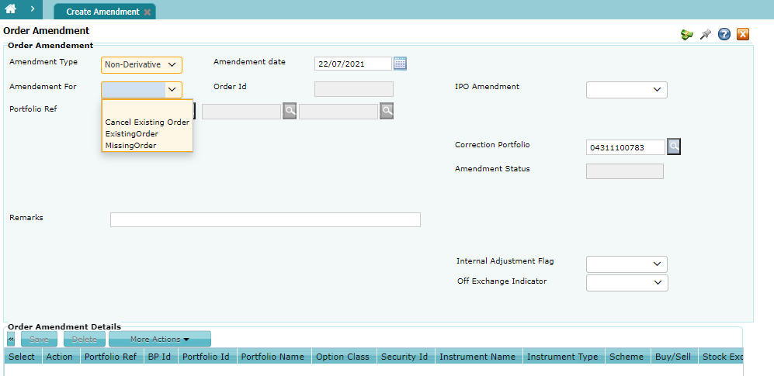

Cancel Existing Order
In this option user will be able to cancel and executed customer order.
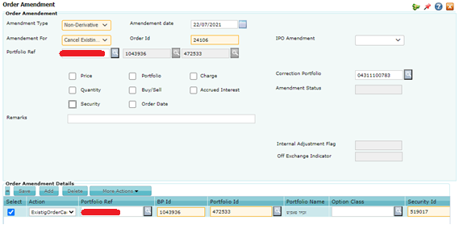

Existing Order (Change or Correction)
BO User will be able to modify the items depicted by check boxes
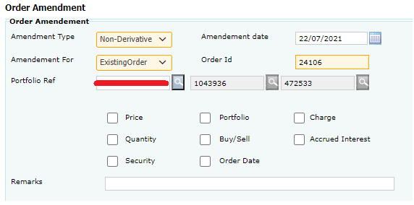

Missing Order (New Order Capture)
In this option BO user will be able to capture an order on customer behalf. By selecting the Add button in the “Order Amendment Details” section.
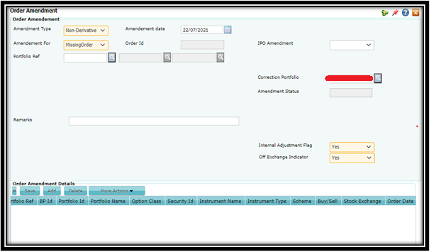

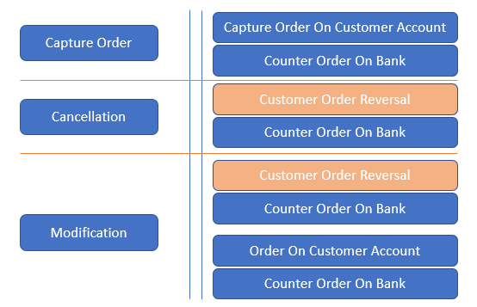

Fractional Order (for left over fraction, full sell)
- Batch Process, to take fractions left over from the full sells during the day. The fraction part needs to be settled between customer account and nostro account/portfolio (Bank Portfolio – configurable) as part of clearing process. System will create a new deal between (Deal category- Transit Deal) client and fraction portfolio as part of file 1052 processing Deal price will be the average price of deals received for order on trading date.

MF trading
- Mutual fund trading parameter
TASE sends trading parameter details in file 126 and these are mapped at product level. System validates order entry as per parameters coming in file 126. This is applicable for all MF orders

- Mutual fund orders can be of two kinds –
- Online MF Orders (during market hours)
- Offline MF Orders (off market hours)

- Mutual Fund allocation and clearing
- Local funds and foreign funds
    - 1051 for allocation -
Clubbed executions are received on fund level in file 1051. Cut off phase is updated from file 544.
    - 1052 for Clearing

Mutual Funds Allocation and settlement
Fund Type | Timing | Process | Settlement Type | Settlement Party | File
Local Market | T(Evening) | Allocation | Security | Customer | 1051
Local Market | T+1(5:30 Pm) | Settlement | Cash | Customer | Contractual/ Actual*
Local Market | T+1(8:30 pm) | Settlement | Cash and Security | Street | 1052
Foreign Funds | T(Evening) | Allocation | Security | Customer | 1051
Foreign Market | T+1(5:30 Pm) | Settlement will be skipped | Cash | Customer | Contractual
Foreign Funds | T+1(Evening) | Allocation Reversal  (Only Movements) | Security | Customer | 1051
Foreign Funds | T+1(Evening) | Allocation with New Price | Security | Customer | 1051
Foreign Funds | T+1(8:30 pm) | Settlement | Cash and Security | Street | 1052
Foreign Market | T+2(5:30 Pm) | Settlement | Cash | Customer | Contractual/ Actual*
Foreign Funds | T+2(8:30) | Settlement Reversal | Cash and Security | Street | 1052
Foreign Funds | T+2(8:30) | Settlement with New Price | Cash and Security | Street | 1052

* According to the bank's decision.
- Mutual fund price correction
- Auto Price correction
Trade reversals and reallocations are received in 1051 file. System reverses old allocation and books at new price as received.

- Manual Price Correction –

- Correct price is updated in Security rates in Market information module.
- Allocation reversal and execution handling screen is present in Bancs for manual price correction. Orders on given fund are reversed using the action “Reversal”.
Orders on given fund are reallocated using the action as “Reallocate”. Orders on given fund are reversed and reallocated using the action as “Reverse and Reallocate”.

Securities Transfers

All securities transfers (in/out) for customer should be compatible to TASE, ISA, ITA, BOI mandatory regulations, deployed in similar way by all the banks, either through system or through some workaround.

There will be two kind of securities transfers- within bank and outside bank.

External bank and branch details to be stored in system for initiating external transfers.
System needs to process incoming interface file for details of transactions initiated from other banks.
Interface file to be generated for external transfers initiated at Bank.
Securities transfers to be restricted on ex-date of corporate action.
Upon Creation of Transfer from customer account Custody blocks will be applied.
AML Check will be done Manually for Transfers.
The BO will receive an alert if there is a security whose date of purchase is before 2002, in compliance with the guidelines of the Tax Authority.
Order Level Transfer Values will be always in ILS (Same for File 132/15) Irrespective of trading currency.
For both within bank and outside bank transfers, the tax lot layers will also be transferred on settlement.
Upon Settlement the custody blocks will be removed, and DR security movement will be written.
Transfer case type to be stored for external stock transfers and in internal transfers where same entity is not selected.
Virtual sell to be supported through transfer functionality. Target and source portfolio to be same for virtual sell transactions.
System will also compute “Same entity tax identifier” flag based on same entity and transfer case values entered in screen.

Same Entity Indicator | Transfer case | Same Entity Tax Identifier
Yes | NA | 1
No | Transfer to spouse | 1
No | Transfer to children Under 18 | 1
No | Transfer to divorce spouse by court order | 1
No | Transfer derived from inheritance by court order | 1
No | Transfer from trustee to beneficiaries | 1
No | Transfer to Relatives | 1
No | Transfer without identification (Tax Event) | 2

- The following transfer sub cases under ‘Transfer between relatives’ need to be included and are tax exempted: -
- Spouse of a sister/brother
- Sister/brother
- Spouse of a mother/father
- Mother/father
- Spouse of a grandmother/grandfather
- Grandmother/grandfather
- Spouse of an off-spring/off-spring of a spouse
- Off-spring/Off-spring of a spouse
- Off-spring of a sister/brother
- Parent’s sister/brother

Type of Securities Transfers

Within Bank

Portfolio Transfer

Supported from both BO and Branch Channel
The user can transfer the securities through within bank to his/her own account number or to account number of his/her relatives in the same bank.

When the user chooses ‘Transfer between the relatives’ in the Transfer case dropdown, the transfer subcase dropdown will be enabled. The transfer subcase will be disabled for remaining scenarios in the Transfer case dropdown. The user can add multiple beneficiaries only when the user selects the scenario ‘Transfer between relatives’ in the Transfer case dropdown. For remaining scenarios, the user can only add a single beneficiary. For Within Bank Transfers, once the order is authorized it will be marked as settled by EOD process. All the securities will be transferred to the target account/portfolio and the transfer status will be “Settled” i.e., the securities will be debited from the source portfolio and credited to the recipient portfolio.

Once the security movements are done, these will be sent to tax engine as per instructed codes and indicators to reflect the updated position as in BaNCS for the customers in tax engine as well.

Virtual Sell

Supported from only BO.
The user can also select the option of ‘Virtual Sell’. By doing so the options for transfer case will be disabled with ‘Self’ option. The transfer subcase dropdown will also be disabled.

For Within Bank Transfers, once the order is authorized it will be marked as settled by EOD process. All the securities will be transferred to the target account/portfolio and the transfer status will be “Settled” i.e., the securities will be debited from the source portfolio and credited to the recipient portfolio.

Once the security movements are done, these will be sent to tax engine as per instructed codes and indicators to reflect the updated position as in BaNCS for the customers in tax engine as well.

Between different Banks

For Outside Bank Transfers (same entity All transfer orders except transfer type=99), the transfers will not be sent to the Stock Exchange immediately. At the beginning of day on the next day, a batch process will pick up the authorized security transfers and send them to the stock exchange (File 15). This should include local holdings and international holdings where transfers are to be sent to another bank within Israel. This is required for transferring of tax layers/lots. Similar process will be applicable for incoming transfer instructions (File 132).
Reconciliation between BaNCS and TASE orders will be done by records received in file 1051. Reconciliation status will be updated at order level and will be displayed in order list screen. Search will be available for reconciliation status field in Stock transfer list screen.
In case of failed trades, failed trade status will be updated at order level in reconciliation status field. Search will be available for reconciliation status field in Stock transfer list screen.
Manual option is required for movement generation for outside bank and international transfers.

BO user will be able to block the transfer and prevent it from reaching the customer's bank account.
For Incoming Transfers if all validations are passed then order is created in Authorized and if some validations fail the order is created in to be repaired status. BO operator has the ability to generate the Incoming transfer’s report and take action accordingly. In case bank want to block some transfer in, then the same should be cancelled at TASE terminal and then also cancel the BO order.

Incoming Transfer (Tase File 132)

Tase file 132 is received and post technical validations, the batch processes and creates “Delivery In” BaNCS system. Any Business exception such as lots and order quantity not matching, recipients account not found, the order will be marked in “To Be Repaired” Status. BO User needs to manually repair the order then for further processing.
Checks during file processing:
- Security Present in System
- Beneficiary Account/Identification mismatch
- Difference between layers quantity and order quantity
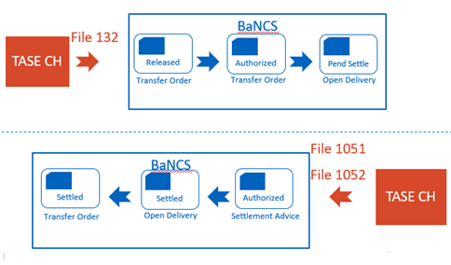

Local Market
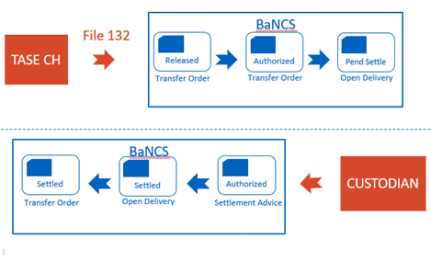

Foreign Market

Outgoing Transfer (Tase File 15)

To be initiated from BO & ST End. When the recipient is not present in FDB, Details related to beneficiary bank/account/id to be provided. For Outside Bank Transfers (same entity All transfer orders except transfer type=99), the transfers will not be sent to the Stock Exchange immediately. At the beginning of day on the next day, a batch process will pick up the authorized security transfers and send them to the stock exchange (File 15). This should include local holdings and international holdings where transfers are to be sent to another bank within Israel. Reconciliation between BaNCS and TASE orders will be done by records received in file1051. Reconciliation status will be updated at order level. Transfer will be settled only when the settlement is received from clearing file 1052.

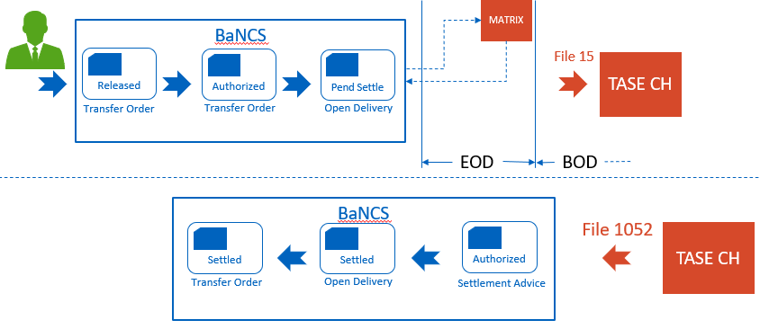
Local Market

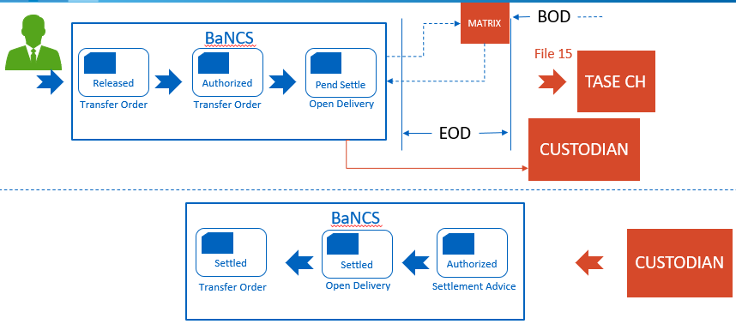

Foreign Market

Delivery In/Out
Initiated via BO only.
To allow the Bank to process

- ADR GDR Conversion BaNCS provide the Delivery in option. BO user to capture this order from BO application, for both legs i.e., CR/DR of different securities. BO user also need to link both transaction via a common key and enter the same in “External Reference 2” Field on screen. In the delivery Type user need to select
  - ADR to Local Sec Conversion
  - Local to ADR Conversion

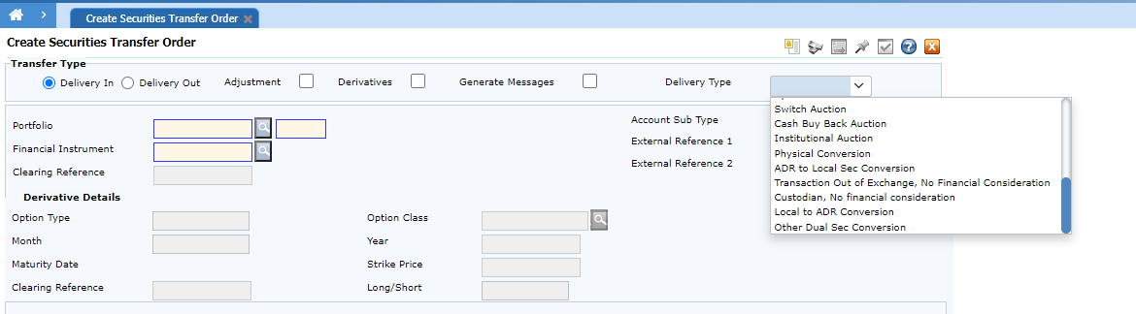

- Third Party Transfer

If a customer opts to transfer his foreign assets to/ from different custodian outside Israel, then this option is used. For this the BO user needs to create a delivery out/ in and select the transfer case as Third party Transfer. This transfer will not be sent to TASE.
The user can extract a report from BaNCS, in order to transfer/ receive the securities through a different custodian.

Report for Third Party Transfer from FDB. Customer Level Jasper report.

Cash and Security Movement creation Flow

Cash Debit & Credit Movements as result of transactions
Movements are generated
  - Real-time as the transaction is processed
  - Double sided Booking
  - Transaction Date, Trade Date, Value Date is stamped
  - Balance is computed on the fly for accounts from movements
Back-dated balance is computed by using the dates stamped in movements
Business transactions are configured as Business Events e.g.
  - Buy Securities Client
  - Buy Securities Broker

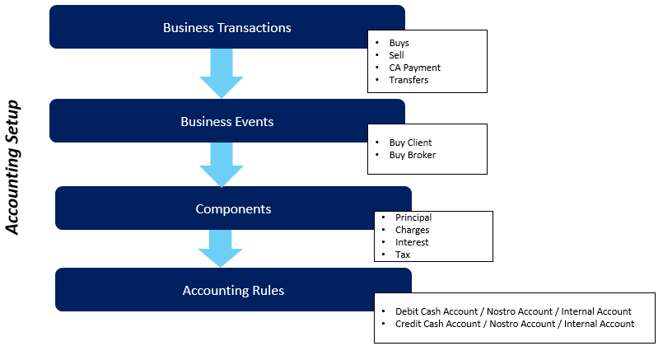
Accounting Setup Hierarchy

- Chart of account setup for creating internal and nostro accounts. Each account can be assigned a BSPL code for accounting classification.

- Accounting rules can be setup to identify the internal accounts to post the movements according to the business events.

- Accounting Parameters can be setup to use default accounts for suspense account posting

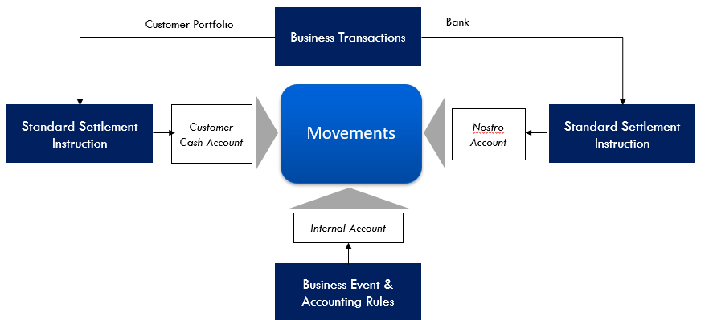

Financial Movement Model

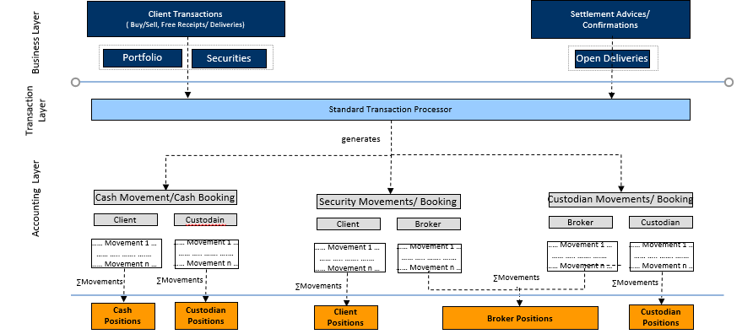
Different Position terminologies

Tax Engine

All the Security Movements (transactions + CA) generated on Business (trade) day are sent to Tax Engine in the EOD process for update of position and lots.
Tax calculations will be on the settlement date of the transactions.

Once the file is uploaded in Tax Engine, EOD will be run for computation of tax and closure of lots, updating of positions in Tax Engine. Upon completion of EOD, Bancs will receive:

- The Tax/Refund details for the Sells/Transfer whose cash settlement/value date is today. BaNCS will post the same to the customer accounts.
- The Updated lots file, this will be shown in valuation screen.
- Open Position per customer + security, to recon the position with Bancs, any mismatches to be analyzed by BO, Onsite Support and Tax Engine support to fix the gaps if any.
- Counters file for previous 10 days trading status of customer from P&L view.

Charges/Commission
All commission and fees should be compatible to TASE, ISA, ITA, BOI, IRS )and to any other regulator to which the Bank is subject) mandatory regulations
Commission setup/ allowed and supervised by BOI “BOI price list section #4” attached.
A detailed demo of the fee capabilities and regulatory reporting functionality available in the base product is provided to the Bank. Bank has not finalized the fee charging structure and there are two options available
- Local market Option 1 - Bank to apply commission from customer in such a manner that TASE fee is also offset. BaNCS will provide a data extract using which Bank can calculate the TASE fee and manually reconcile with 1091
- Local market option 2 – If TASE trading fee structure can be setup without any change then Bank can add commission and TASE fee as two different charge items and accounting can be done accordingly.
- TASE fee setup for other activities will not be possible in the system and will need to be checked manually

- Foreign market – Charges will be applied as per the broker trade reconciliation file received from the broker. TAF fee calculation can’t be supported as it is calculated across customers.
- No other third party charges or internal charges are known as of now. If there are additional charges, the same need to be discussed with BaNCS and it may need change process for making any changes to setup and calculation process
, deployed in similar way by all the banks, either through system or through some manual workaround. The fee and commission setup capabilities are shared with the Bank and any changes to the setup capabilities will be done via a change process. If a given regulation has different options and Bank wants to take a specific option not available in BaNCS then it will be done on chargeable basis.

The charges charged from the clients can be broadly classified into two groups.
- Transaction based charges
A transaction-based charge is charged whenever services like a Forex deal (& Securities) are availed by a client. The charges to be charged on these types of operations is based on the economic value of the business operation. These charges are linked to the business operation or its value.

Charges related to a particular type of transaction are under this category. For example Bancs have “ST Allocation, Order Modification, Order Cancellation” as a chargeable transaction that is configured in the system. On this transaction bank can apply various type of fee which are termed as “Charge item” like ST Commission, Modification fee, Cancellation fee” which can further be configured as percentage/ flat amount on transaction amount or the fee amount coming from ST in the trade execution.

- Periodic charges
These are not linked to a business operation or its value but are decided based on the services availed by the client. For example, maintenance of numbered accounts.

Standard fee packages will be created at the bank level for the services offered by the bank. All the clients will be linked to one of these. The linked fee package then becomes the default fee package for a client and all computation of charges for a client will be done based on this. It will contain one or more component as defined below for each of the service (chargeable transaction) offered at the level:
- Fee Schedule: A fee schedule will contain following details:
- Chargeable Transaction: It represents the service for which charge is specified.
- Charge Item: It represents the component attached to a service or a chargeable transaction. For example, brokerage can be one of the charge items that may be charged for settlement services.
- Charge Type: For each charge item the charges are calculated based on the charge bases along with the associated charge type. They are:
- Flat
- Flat percentage
- Incremental slab amount
- Incremental slab percentage
- Final slab amount
- Final slab percentage
- Incremental tier
- Final tier
- Flat per unit
- Third party Fees should be implemented (TAF,SEC, etc.)

Charge Basis: The charges can be calculated based on:
- Value of a transaction
- Number of transactions (Minimum fee should be allocated to all exactions of the same order at the same day).
- Value of a position (and translation to different currency)
- Bank : Security type and market as per data available in BaNCS

Bank : Charge : The charges can also be defined as follows:
- Transaction between the same customer.
- Transaction when customer is closing the account

- Maximum and Minimum Amount: The charges can be subject to minimum or maximum levels if the computed charge recedes or exceeds the limit.
- Application Frequency: It specifies when the charge must be settled. This can have values immediately or deferred.
- Computation Frequency: It specifies the periodicity of charge computation for the periodic and tiered charges.
- Charge Amount: It specifies the amount to be charged when charge type is flat.
- Charge Percentage: It specifies the percentage of the charge basis to be charged when charge type is flat percentage.
- Tier Definition: It represents the charges for slab or tier when a charge type is defined as slab or tiered.
- Rule Base Charge: The charges may be affected by factors like order type (buy or sell), instrument type (equity or debt), value of account(s), value of portfolio(s), client category. These factors may override the default charges defined in the fee schedule for a service or may be used for providing differential charges, that is levying lower or higher charges than the calculated one.
- Foreign fee – BaNCS will provide a monthly data extract to Bank listing calculation of broker commission based on trade in BaNCS vis-a-vis commission charged by the broker.
- Also daily reconciliation report should be produced for executions being charged by the broker /custodian - over the fee agreement (SEC,TAF.etc.).
- In case the bank don’t have distribution agreement with the MF manager - the customer position should fee should be calculated on daily basis and might be charged periodically according to the bank decision.

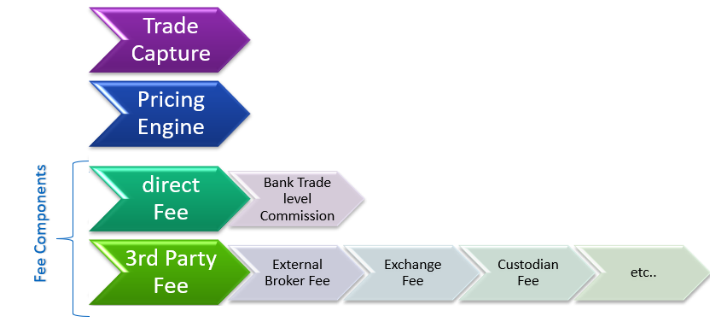
Charges flow for trade

Custody Fee
Daily process for Custody Fee:

Batch Process is computing custody fee on security amount for an instrument daily and store as a sum of custody fee computed for all portfolio holdings irrespective of its type local, foreign, or non-tradable assets.
Batch Process is re-computing custody fee in case of any back dated trade correction or position correction.

Quarterly Aggregation process is run and then the fee is applied to the customer.

Below Message to show applied custody fee
Message 77 / 425
Report- Custody Fee collection (RPS31290) – This report required changes in section Quarterly custody

Commission reports
All commission and fees should be compatible to TASE, ISA, ITA, BOI, IRS )and to any other regulator to which the Bank is subject) mandatory regulations

Reporting commissions/fees (averages, price list, “specific for customer”)
- Reporting to TASE (the report to TASE is not only for averages of what has been charged, but also reporting price list)
    - Files 814/815 according to latest version of the document.
    - The part of 814 that is called “averages” has the same logic/calculations as “414 to customer – section A”, but note that these two are completely different interfaces (814 is file-to-TASE, the other is notification-to-customer + website)
    - The other part of the 814 is the “price list” part.
- Reporting to Customer
- This is according to Directive 414 of BOI (3 notifications/reports to customer: A, B ,C. Note that A appears both as notification and on website)
- Section A of the report to customer is about “averages” as mentioned above (similar logic as TASE 814 – first part). Assuming that everything is clear about the format and the logic of how to gather the info, all that is left is to discuss the requirement for this section to be “published on the website” (in addition to regular notifications to customer). As said, this section A is the only section that appears both as notification and on website.
    - CSV Format Extract to be provided to Bank at Bank vault. ( should be summation of all the customers data ).
- Section B of the report lists all entries of buy/sell/redemption commissions charged (from customer X account) within the period. (report = notification)
- Section C of the report lists per security (security_name) the charges related to safekeeping fees (from customer X account) plus respective holdings. (report = notification)
- Commissions/fees under supervision of BOI
“BOI price list – Securities” (actually it’s more like “what fees are supervised and what fees are allowed” and not much of a price list)

Message 77 Document attached for the reference to BOI regulation.

Position Recon

Bancs reconciliation module is used for recon between various partner systems for position recon.
Below are the three-position recon applicable for FDB.

Local Securities
BaNCS will upload Tase file 1053 for reconciling positions traded on tase as part of EOD process.
Any mismatches are presented in the reconciliation module with ageing.

Foreign Securities
Bancs will upload 871 from apex for reconciling positions traded on tase as part of EOD process.
Any mismatches are presented in the reconciliation module with ageing.

Tax Engine (local + Foreign)
Bancs will upload the file for position customer + security level from Tax Engine and recon with the position from Bancs as part of EOD.
Any mismatches are presented in the reconciliation module with ageing.
Reports can be extracted by the BO user for all the above using export to excel from BackOffice.

Cash Recon (Net Settlement)

Local Securities
BaNCS will provide a data extract from file 32 vis-à-vis data available in BaNCS (Trading charges data can be made available only if TASE trading charge schedule can be setup in BaNCS).

1091 report will be augmented with additional data
- Portfolio ID
- Security Type/Security Sub Type (Tase)
- BaNCS Order Id
- BaNCS Allocation ID
- BaNCS computed Commission ( as per setup) at trade level.

Foreign Securities
BaNCS will generate a data extract as per the aggregation key from file 872 and Bank will need to match the same with file 872.
Other fees - All ECN, FINRA TAF, SEC, Regulatory fees, market center, NSCC, and related fees. BaNCS fee capabilities are already demonstrated and no discussion have happened on any of the above mentioned fees. It is possible that some of these fee calculation logic may not be available in BaNCS and the same need to be built on change process basis. Executions report should be produced by BaNCS which contain all fees the customer was charged per execution.
BO will reconcile file 872 (which contains the actual fees that were charged by the custodian) vs the BaNCS report in order to refund the customers the overcharged fees.
TAF and SEC fees are only applicable to SELL trades. TAF And SEC fee will be applied as-is based on the broker recon file and no calculation is being done in the system

BO Reports & Messages

All messages & reports to customer should be compatible to TASE, ISA, ITA, BOI, IRS )and to any other regulator to which the Bank is subject) mandatory regulations, deployed in similar way by all the banks, either through system or through some workaround. (Including the content and the timing for sending these messages & reports). BaNCS EOD message inventory is already provided and any addition of messages will be done on change control basis.
- BaNCS has already provided a list of EOD And online event which will be sent to platform.
- FDB will define a static doc (template) with the as-is dynamic params. BaNCS will generate a doc to the customer's inbox (EOD).
All reports to BO in FDB are subject to mutual agreement after all report details will displayed/shared.

S.No |  | MNEMONIC |  | Desc |  | Applicable Y/N
1 |  | RSP34260 |  | TASE Clearing and Settlement Report
2 |  | RSP34290 |  | TASE Event Reconciliation Exception Report
4 |  | RSP34280 |  | Failed and Cancelled Trades Files 1054
5 |  | RSP34400 |  | Fractional Trading Report
6 |  | RSP34410 |  | Technical Short Report
7 |  | RSP36690 |  | Short Position Report
9 |  | RSP36710 |  | Portfolio Position Report
10 |  | RSP34100 |  | Security Transfer Details
13 |  | RSP33434 |  | Transfers for free b/w relatives in Off exch txn Including Layer Details (tax impact and layers) and commission.
14 |  | RSP35540 |  | Security Transfer-Layer Details
19 |  | RSP36700 |  | Foreign Securities Trade Reconciliation |  | To be reviewed if it can re-used for FDB
20 |  | RSP35490 |  | Distribution Fee - Daily fee report
21 |  | RSP34360 |  | Tase Securities position Recon exception reports
25 |  | RSP37180 |  | Transactions and holdings for Foreign Securities
26 |  | RSP34240 |  | CASH CLEARING FOR TASE
27 |  | RSP36720 |  | PORTFOLIO POSITION REPORT
32 |  | RSP34101 |  | Incoming Security Transfers report
39 |  | RSP32250 |  | Exchange rates for foreign currency
41 |  | RSP31780 |  | Transactions and holdings for Foreign Securities
49 |  | RSP35491 |  | Distribution Fee - Monthly Fee Report (One for each MF manager and one for the FDB
55 |  | RSP34390 |  | Custody Fee Report
56 |  | RSP31150 |  | Daily balance in securities - exceptions report
57 |  | RSP19009 |  | Tax Control Report
58 |  | RSP34570 |  | Transaction Control Report
59 |  | RSP319010 |  | Tax control reports
60 |  | RSP33434_1 |  | Transfers for free bw relatives in Off exch txn
62 |  | RSP34210 |  | Security Transfer Details
63 |  | RSP33435_1 |  | Report from TASE of transfer between relatives
65 |  | RSP3939 |  | Daily Control Reports
67 |  | RSP33435 |  | Report for TASE of transfer between relatives
68 |  | RSP37960 |  | Accounts with Securities/Deposits under foreclosure
69 |  | RSP3939_1 |  | Daily Control Reports
70 |  | RSP2505 |  | Fees for TASE real time rates requests
 |  |  | Fees for CBOE real time rates requests |  | RSP2505
 |  |  | Foreign securities reports (872, 870, active report) |  | Data extract as mentioned in the foreign settlement section
 |  |  | Self (cross) transaction block |  | --NA fo BO
 |  |  | Commissions- Fees for debiting the bank from foreign securities |  | Data-extract EOM. Fields to be decided later
 |  |  | DF / RF instructions for the custodian |  | Jasper Report -
 |  |  | Commission to TASE |  | 814/815
 |  |  | Commission to BOI |  | Nothing for BOI w.r.t commission.
 |  |  | Report to match orders as reported by broker (EOD) including the ones not executed, with orders captured in BaNCS (both through the app and CC system) |  | Broker Average price file recon as mentioned in Foreign trading section
 |  |  | Securities lien report |  | To provide the navigation from BO screen for extract
 |  |  | Dependent transaction report |  | Data Extracts for CA/Trades (open) on daily Basis
 |  |  | “Short positions” by customers’ portfolios |  | First trading day and last trading day in this week

Distribution Fees (MF)

The Fund Manager Pays the Fees to the bank.
There is an agreement between Fund Manager and Bank, based on which the Fund manager pays distribution fee to Bank. The fee is based on the Value of Fund units held by all customers (Exchange/Magna will send the Fund Type, based on this Fee % will be derived). Fee accrual is done every day on the holdings valued at price(NAV) for the same day. At the calendar month end, a fee report per fund per Fund Manager is generated where holding is not zero. For the mutual funds, via tase and magna, a user definable data (indicator -- d_UsrDefData_MFPolicy) is set at product level, and the same is used whether to charge the MF manager, the customer or not to charge. Computation takes in account the leap years extra day for deriving the charge amount accordingly. This process is done before generation of the below report.
In case the bank doesn’t have distribution agreement with MF manager, the customer might be charged with calculated distribution fee according to the bank decision. However Customers cannot be charged for distribution fees on Money-Market fund and the distribution fee will not be charged from the customer.
Report Columns are
Mutual Fund ID |Fund Manager Name| Total Sec Qty | Exempted Holding | Total Sec Value | Total Charge Amount | Date of Generation| Rate | Currency | Fund Category |Distribution Fee
Fund manager will receive this report along with a cover letter with the total fee for this month. To send these documents to a secure email of MF manager, these documents will be produced automatically, and separately, either in Excel or in textual PDF or CSV formats. In addition, an event will be sent to Kafka for each MF documents.
A summery report of all FDB holdings as similar to the MF manager report will be also generate for the BO.
Some dynamic data extract to support the report and calculations of Distribution Fee can be done from BaNCS upon such scenario.

Validation for external files
Alerting mechanism required for failures of File delivery from Source.
Failure of interfaces and skip items from batches are notified by CTRLM to Onsite Support. Item is configurable at onsite only.
Validations on the field level: data type, format, length
Interface incoming and outgoing, there are field level validations (technical)
Validation for information in the field
Cannot be handled via technical layer (interfaces)

BaNCS Gap
Gap ID | Business Area | Details
SP-BackOffice-01 | Portfolio transfer | ‘Transfer to relative’ domain transfer sub case value 9 needs to be split into two different values - Off-spring of a sister/brother & Parent’s sister/brother
SP-BackOffice-02 | Portfolio transfer | Generate a report on request listing the transfer securities details per portfolio which need to be sent to APEX. Please refer to document attached under section 1.9.3 à Third party transfer
SP-BackOffice-03 | Foreign trading | Monthly extract for calculation of broker commission and compare the total fee charged by the broker,
SP-BackOffice-04 | Foreign Settlement | New batch process for settlement of foreign trades marked as ‘matched’ on settlement date
SP-BackOffice-05 | Local commission recon | Provide a data extract to recon listing the trades and respective TASE commission (Possible only if we can setup TASE trading fee structure)
SP-BackOffice-06 | Failed Settlement | Data extract listing OD open beyond settlement date
Recon-Commission-01 | Trade level commission matching | Commission matching process for trading only (If setup of TASE fee structure is possible)
SP-BackOffice-07 | POA Order Placement Handling via only FO | POA to an account cannot place orders via Internet or Mobile application. Only from FO it should be allowed
SP-BackOffice-08 | Valuation Extract | Extract for all customer holding security.  Fields  Customer Account | Total value of the portfolio (ILS) | Value of securities traded in TASE | Value of securities traded in OTHER exchanges (ILS)|

